

# Investment Newsletter

## *October 2012 for Harvest Clients*

This Newsletter is provided to all Harvest clients & corporate contacts to keep you better informed on matters regarding super and wealth. It provides a high level overview of key investment market influences and recent market performance. For further information, please contact Harvest on **02 8908 4300 or www.harvestgroup.com.au**.

Investment Newsletter October 2012

**Australian Economic Data Generally Soft**

House prices have fallen over the last year, however rose in September 2012. Retail sales were up slightly in August but below long term average levels. Business conditions for manufacturing, services and construction have weakened and inflation in September only rose slightly.

10 Year Spanish and Italian Sovereign Bond Yields

**US Positive Economic Data**

The Institute for Supply Management (ISM) business conditions index rose, unemployment rate dropped to 7.8% (below 8% for the first time since the Global Financial Crisis), consumer credit rose and the central bank announced a third round of quantitative easing (i.e. QE 3). This is expected to result in continued rising investor confidence in the US.

**Spain’s Sovereign Debt**

Spanish short term Government bond yields have come down significantly since the European Central Bank commenced purchasing these bonds in the open market. However, it is expected that Spain will eventually need to apply for assistance from the EU (European Union).

Global equity markets have performed strongly for the quarter ending 30 September 2012. Some key developments influencing markets at the moment include:

**Australian Cash Rate**

The Reserve Bank of Australia (RBA) has dropped the official cash rate to 3.25% pa mainly due to a softening global economic outlook, slowing growth in China (and the developing world), and the need to stimulate the non-mining sectors of the Australian economy.

**Chinese Growth Slowing**

Economic growth in China is slowing as reflected by a fall in the manufacturing and non-manufacturing PMI indexes. However the non-manufacturing index remains relatively high.

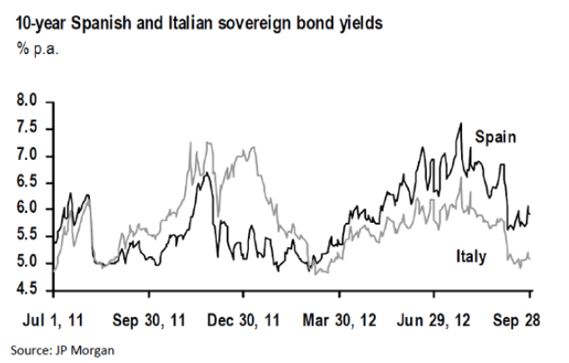

**The Australian Share market rallied in the September 2012 quarter. The rise largely reflects an increase in the market Price Earnings ratio (Globally there is rising confidence that the developed world can manage Sovereign Debt issues, however Global economic growth is slowing to around 3% pa. We expect the Australian Equity market as measured by the ASX 200 index to now trade in the range of 4,300 to 4,800 for the rest of the 2012 calendar year.**

© Prepared by Harvest – October 2012 Page 1 of 2

Source: JP Morgan

Investment Market Update



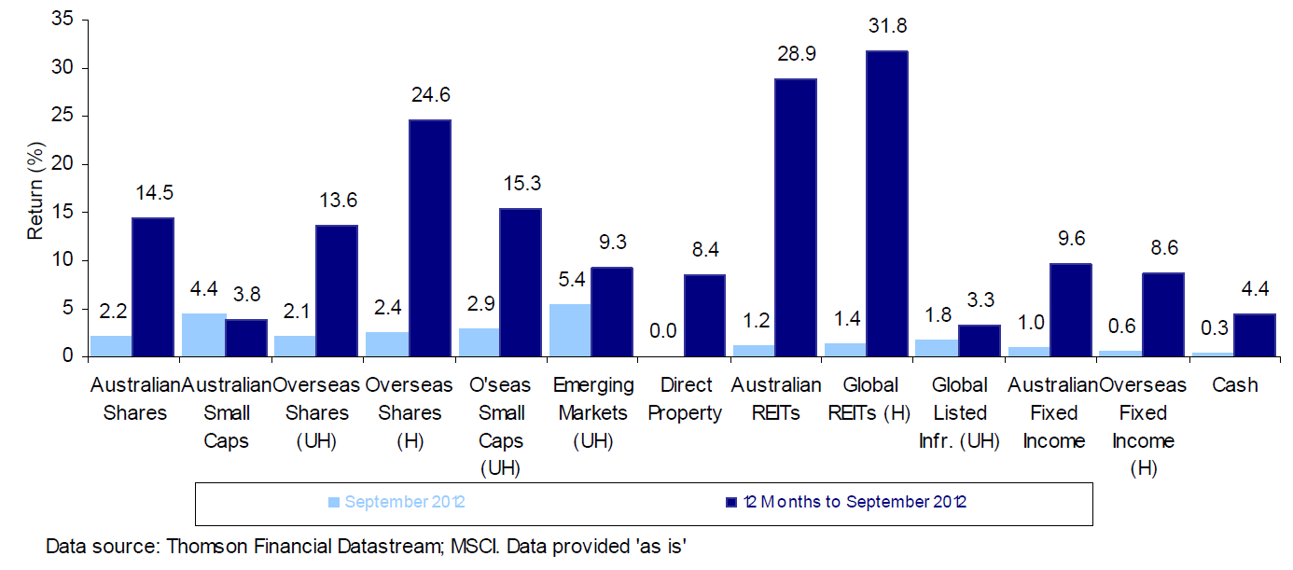

Source: Thomson Financial Datastream; MSCI data provided ‘as is’

**Fixed Interest**

In Australia, Commonwealth bond yields increased slightly resulting in a +0.6% return for the month of September (as measured by the UBS Treasury Bond Index). Global bond returns were +0.6% as measured by the Citigroup World Government Bond (ex-Australia) Index.

**Australian Dollar**

The Australian dollar weakened during the month due to concerns about Chinese and World economic growth slowing, resulting in lower commodity prices. The $A rose against the US dollar (+0.6%) in September.

**GENERAL ADVICE WARNING**

© 2012 Harvest Employee Benefits. This Newsletter has been prepared for Harvest’s clients. The information contained herein is current and up to date at the time it was prepared. Harvest Employee Benefits Pty Ltd, ABN 74 107 226 693 is a Corporate Authorised Representative and Mario Isaias, Noel Hucker and Inbam Devadason are Authorised Representatives of Harvest Financial Group Pty Ltd, ABN 80 111 998 068 AFS Licence No 284909. Harvest reserves the right to correct any errors or omissions. Any advice contained herein has been prepared without taking into account any individual persons objectives, financial situation or needs. As such, before acting on any information contained herein, a person should consider whether the information is appropriate for that person, having regard to their objectives, financial situation and needs. The relevant Product Disclosure Statement should be obtained and read before making any decision regarding information contained in this Newsletter.

**Australian Shares**

The local market was up in September. The S&P ASX 300 Index returned +2.2% for the month. Investors favoured stocks in Material and Healthcare. Small companies also performed well, up 4.4% for the month.

**Overseas Shares**

Most global equity markets posted strong gains in September, as investors began to feel that the Sovereign debt issues can be managed through central banks buying bonds to keep interest rates at manageable levels.

The MSCI World Index returned +2.8% in US dollar terms and +2.1% in $A terms (as the $A dropped over the month). The S&P 500 index returned +2.6%, while the NASDAQ returned +1.6% local currency terms.

European markets were generally also up - the German DAX 30 (+3.5), the French CAC 40 (-1.2%) and the UK FTSE 100 (+0.7%).

Asian markets were also strong with Japan up (TOPIX +1.8%). Chinese markets were down (Shanghai Composite +1.9%). Hong Kong was also down (Hang Seng +7.5%).

**Property**

Domestic REITs as measured by the benchmark S&P/ASX 300 A-REIT Index finished the month up +1.2%). Global REITs appreciated 1.4% (as measured by the FTSE EPRA/NAREIT Developed Index) on a fully hedged basis.

© Prepared by Harvest – October 2012 Pg 2 of 2

Selected Market Indicators Commentary for the Month Ending 30 Sep 2012

Asset Cass Returns

Market Action by Asset Class

Investment Newsletter October 2012